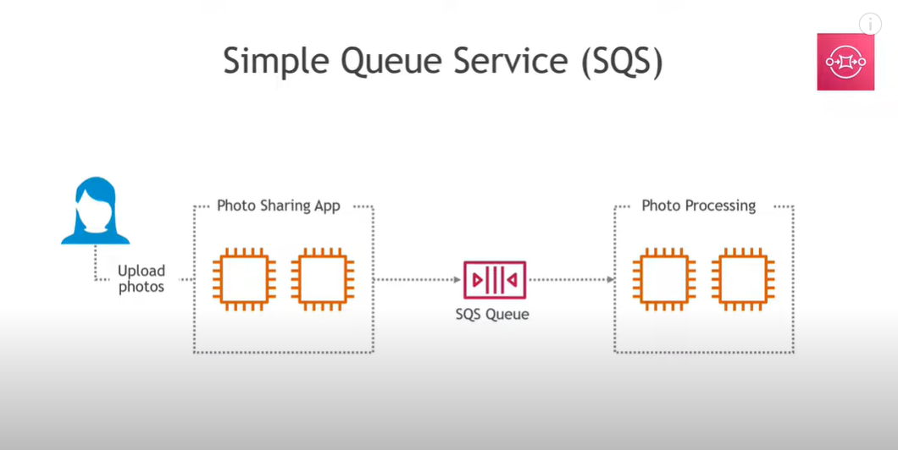

**SQS Purpose** Managed message queuing service to decouple and scale microservices.

**Amazon MQ Purpose** Managed message broker (RabbitMQ, ActiveMQ) for applications using standard protocols (JMS, AMQP, etc.)

**Key Differences**

* **SQS**: Simple, scalable, fully managed, works with AWS native apps.
* **Amazon MQ**: For existing apps requiring traditional brokers.

## **Example Task SQS: create a queue and send a message.**

## **Step 1: Create a Queue**

1. Go to **AWS Console → SQS → Create Queue**.
2. Select **Standard Queue** (FIFO queues behave slightly differently).
3. Give it a name: demo-queue.
4. Keep default settings (Visibility Timeout = 30 seconds).
5. Click **Create Queue**.

## **Step 2: Send a Message**

1. Open your queue → Click **Send and receive messages**.
2. In the “Message body” type something like:

Hello, this is my first message!

## **Step 3: Poll for Messages**

1. In the same screen → Click **Poll for messages**.
2. You’ll see your message appear in the message list.

👉 At this point, the message is **NOT deleted**. It just became *invisible* for the **Visibility Timeout** (30s default).

## **Step 4: Check Another Tab**

1. Open the queue in another browser tab.
2. Try **Poll for messages** immediately → You will NOT see the message.  
   * That’s because the **first tab has a lock on it for 30 seconds**.
   * This lock is called **Visibility Timeout**.

## **Step 5: Wait or Delete**

* If you **wait 30 seconds** and then poll again → The message will reappear (since it wasn’t deleted).
* If you **delete the message** from the first tab → It will be removed permanently and won’t show again.

✅ **Key Learning:**

* **Send → Poll → Delete** is the full lifecycle.
* If you don’t delete, the message keeps reappearing after timeout.

1. 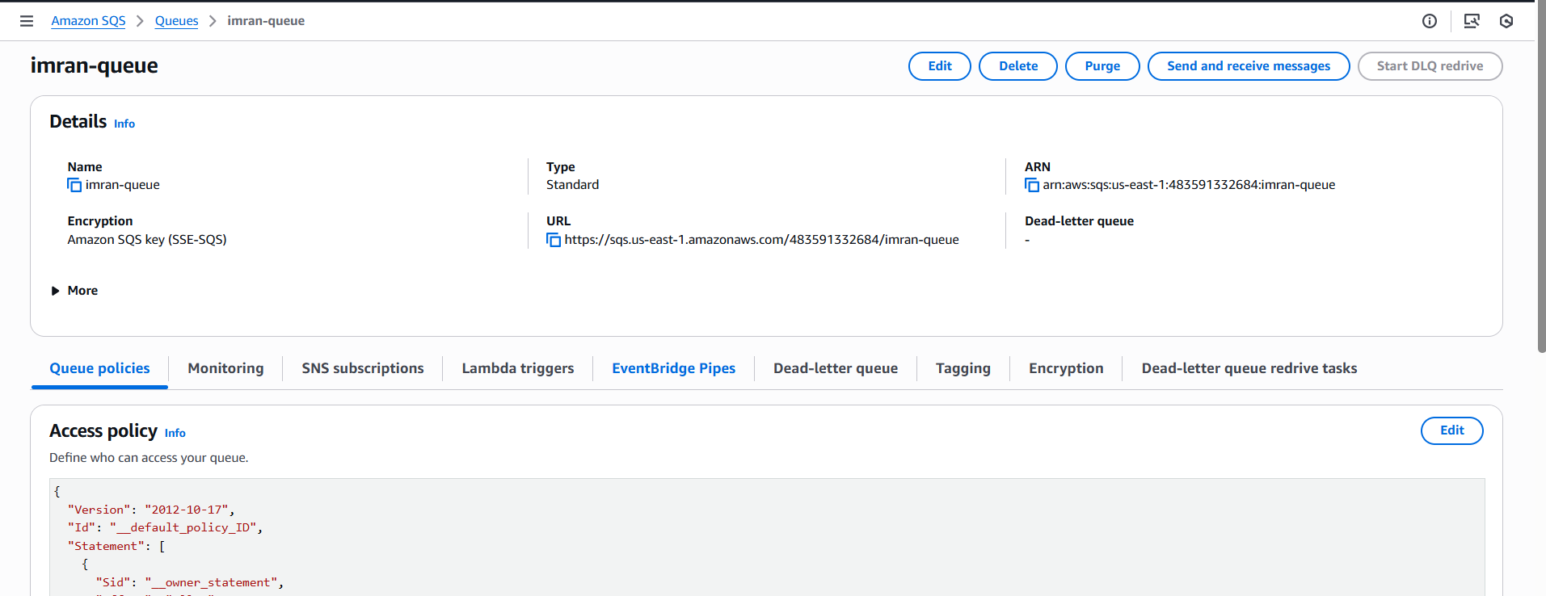
2. Send message
3. 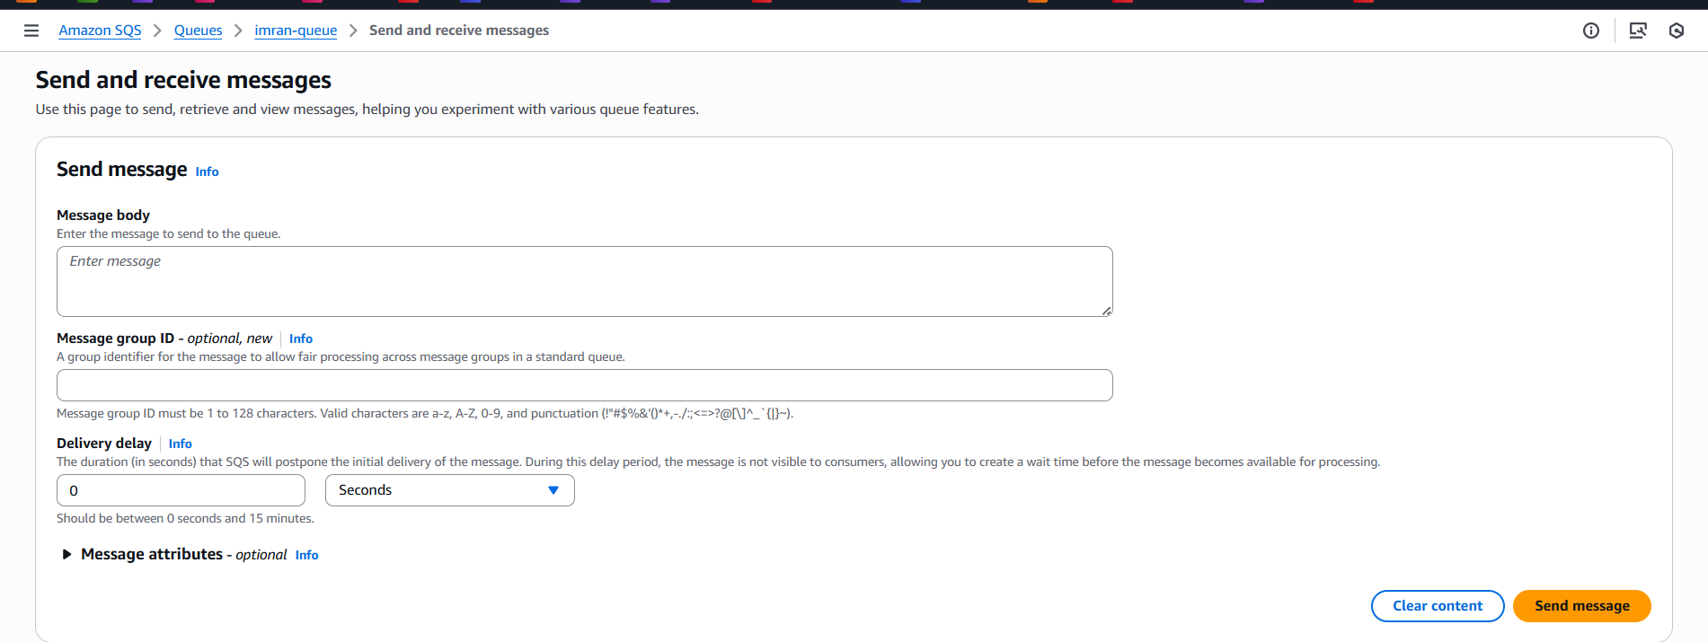
4. Poll for messages
5. 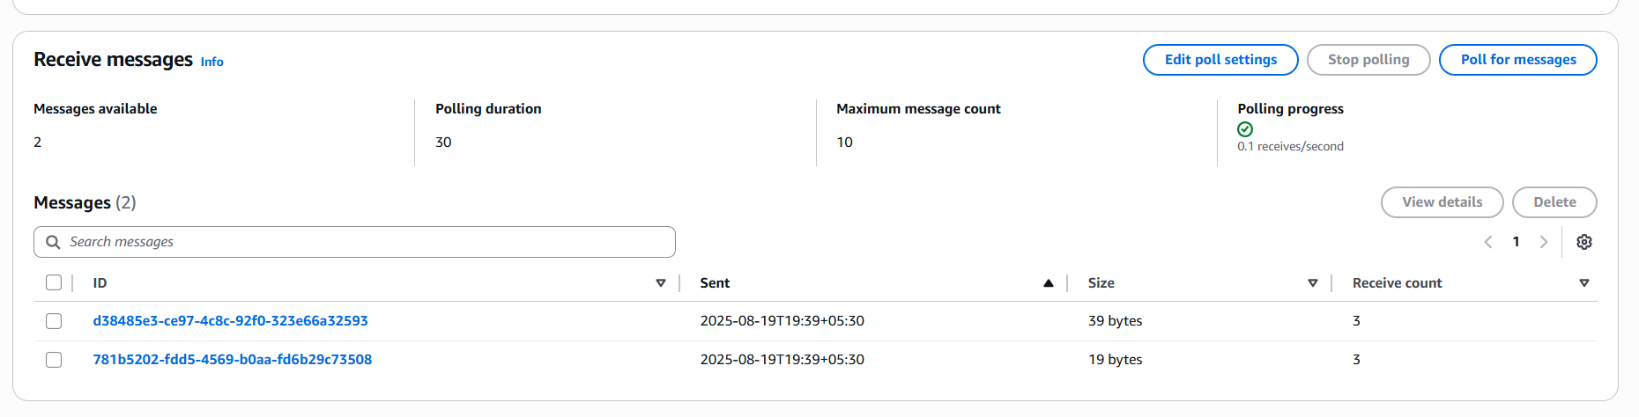
6. Check in another tab
7. 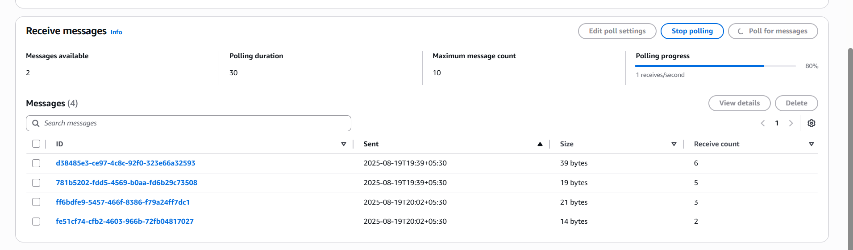

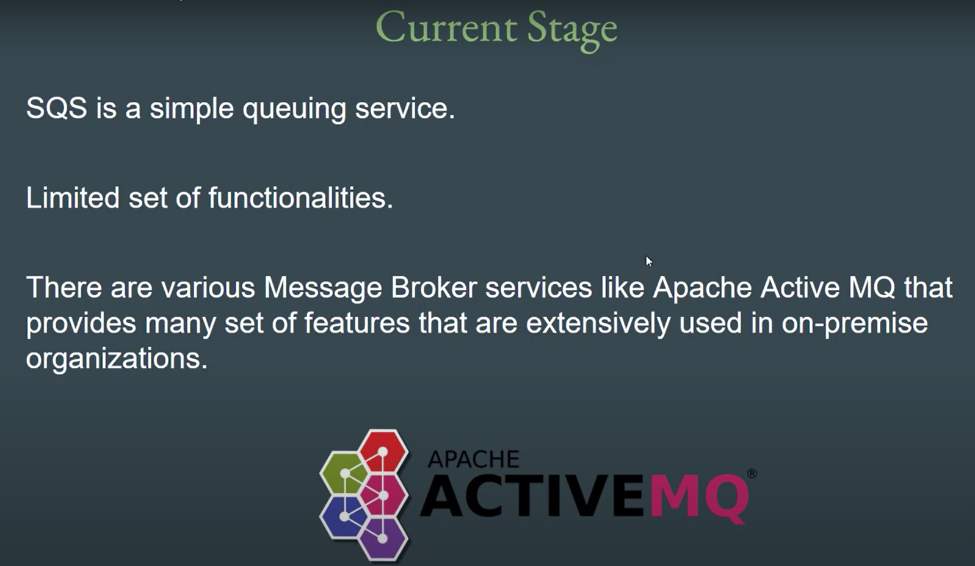

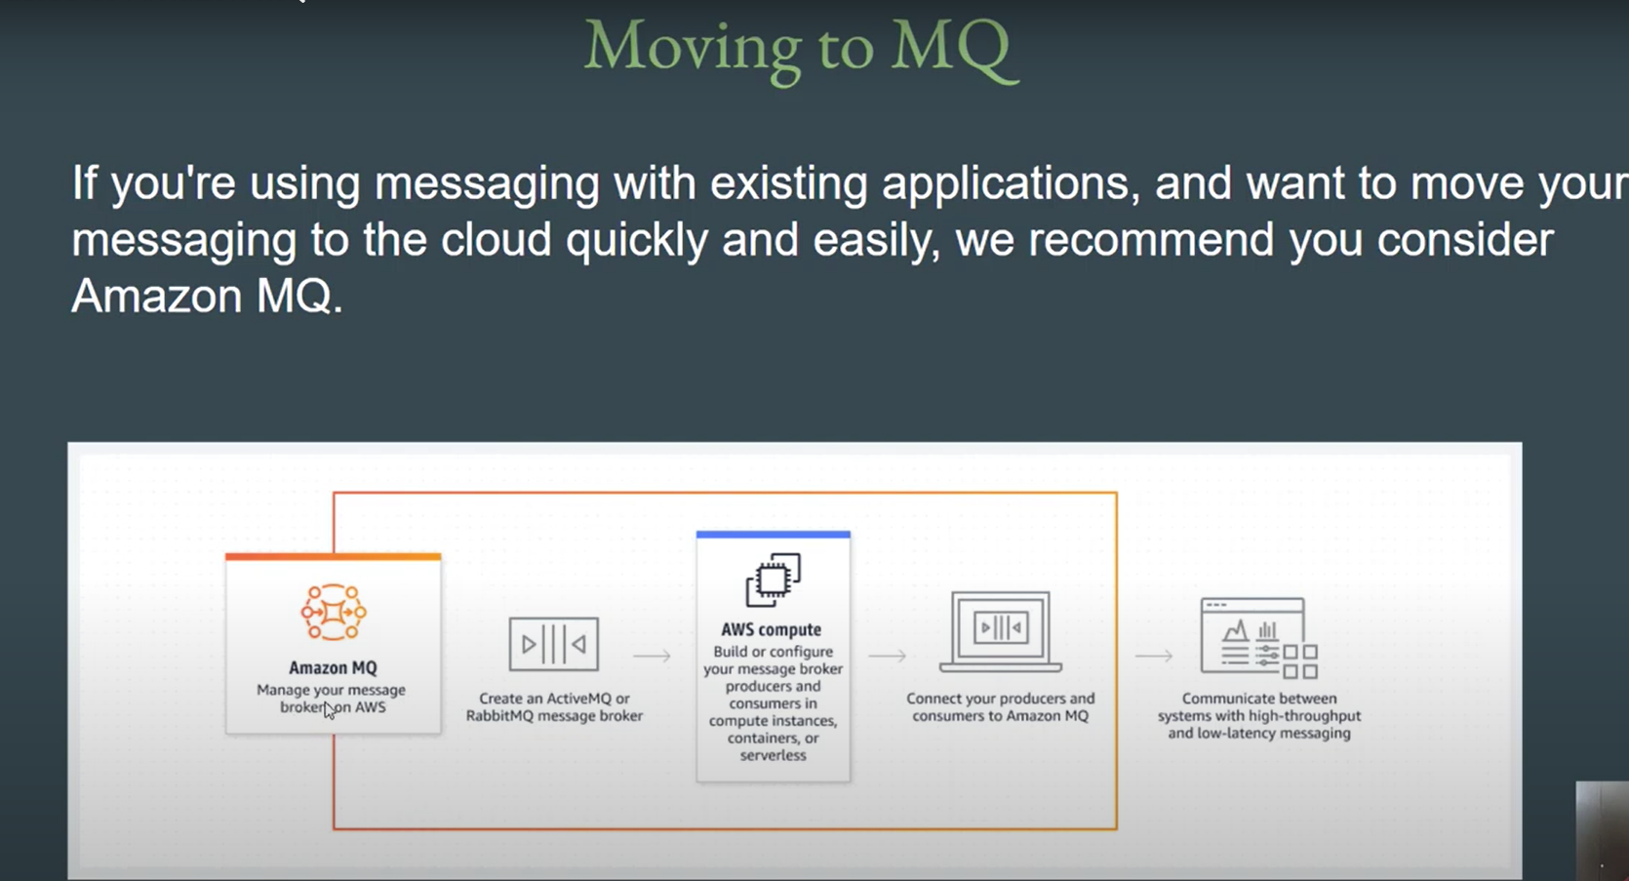

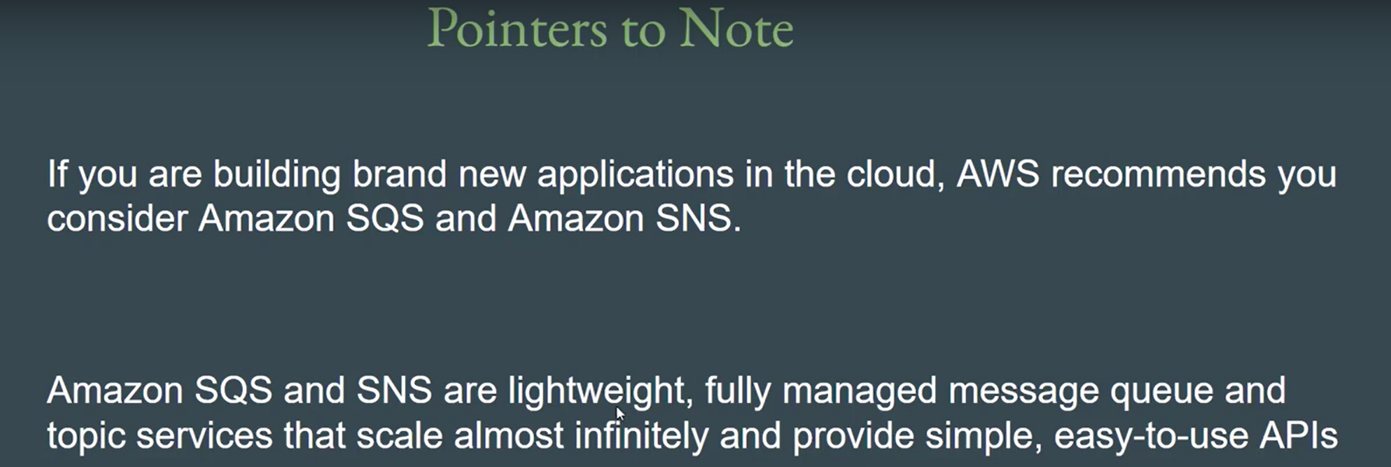

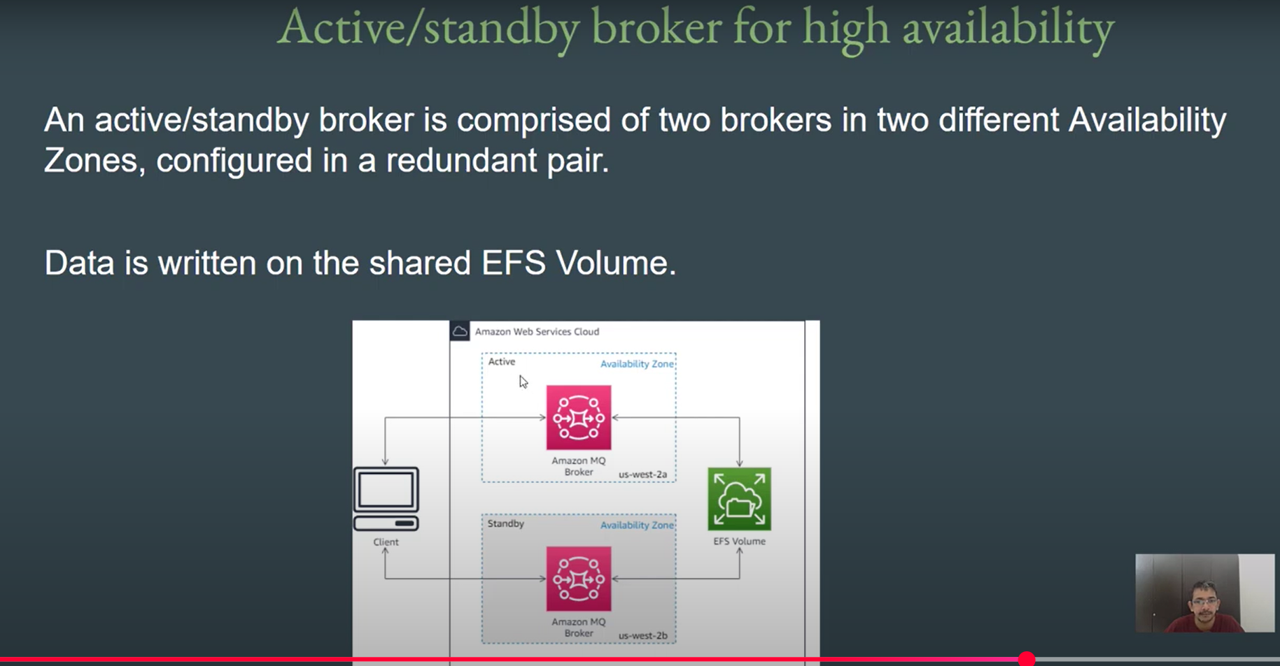

1. Created a imran-mq
2. 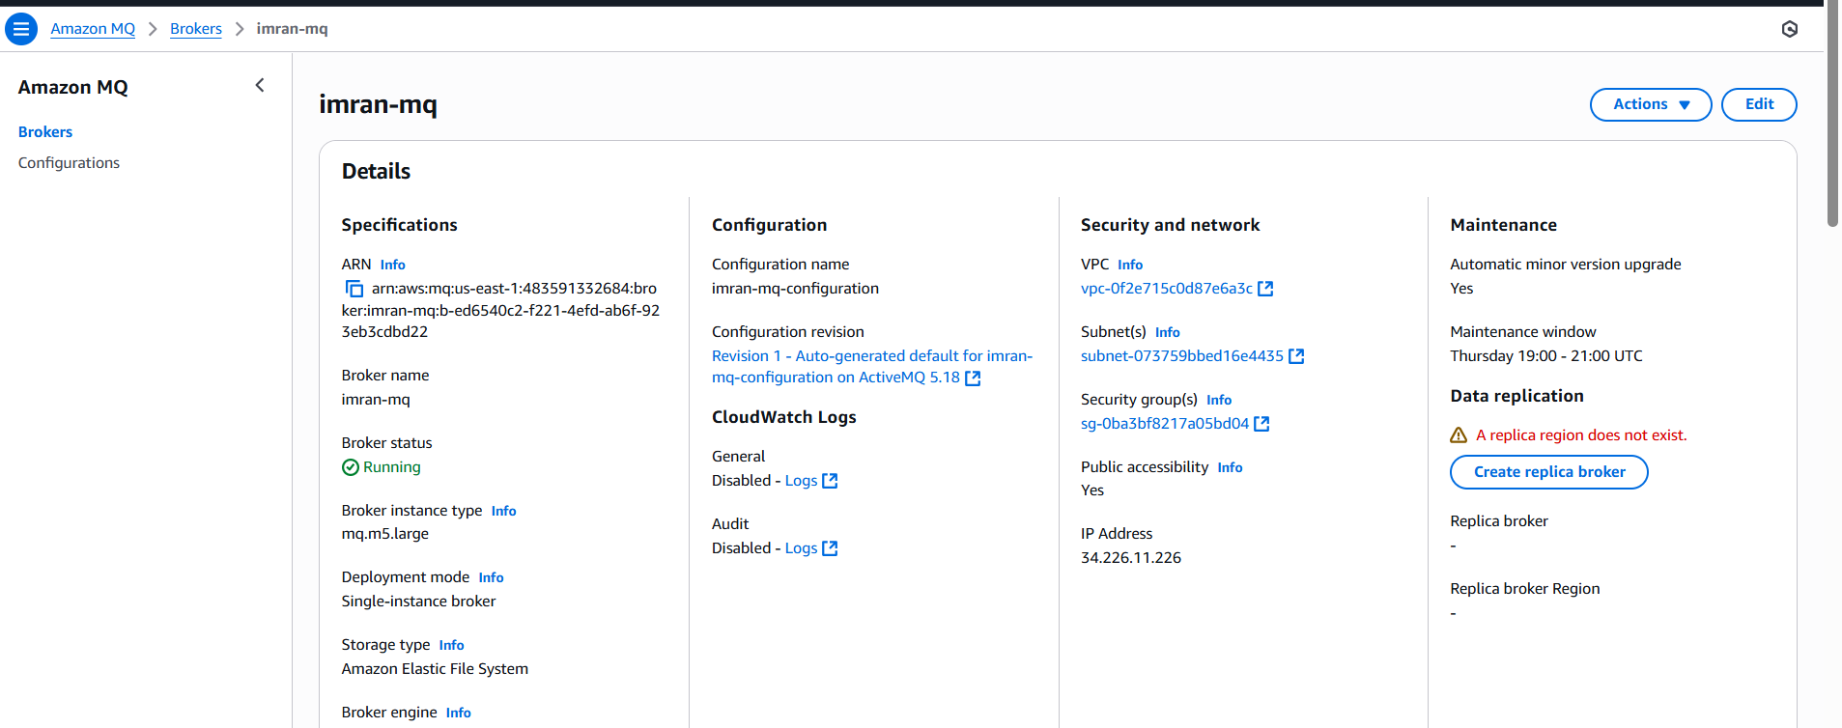
3. [https://b-ed6540c2-f221-4efd-ab6f-923eb3cdbd22-1.mq.us-east-1.amazonaws.com:8162](https://b-ed6540c2-f221-4efd-ab6f-923eb3cdbd22-1.mq.us-east-1.amazonaws.com:8162/)
4. 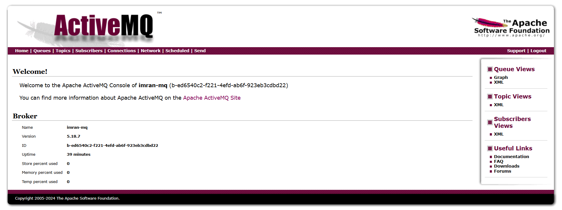
5. In imran-mq created a test queue and send the message
6. 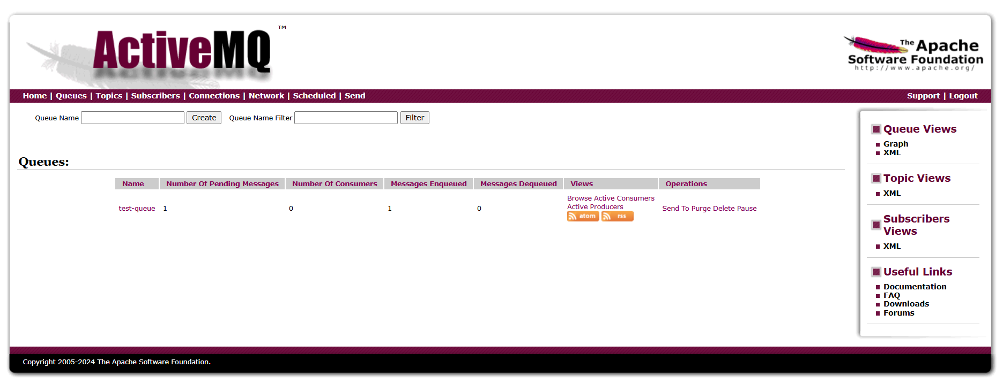
7. You can find the message
8. 